H.T No
Regulations:
A20

Sreenidhi Institute of Science and Technology
(An Autonomous Institution)
Code No: 8HC12 Date: 28-Aug-2023 (FN)

B.Tech I-Year II- Semester External Examination, Aug/Sept-2023 (Supplementary)
DIFFERENTIAL EQUATIONS & INTEGRAL CALCULUS (CIVIL and ME)

Time: 3 Hours Max.Marks:70

Note: a) No additional answer sheets will be provided.
b) All sub-parts of a question must be answered at one place only, otherwise it will not be valued.
c) Missing data can be assumed suitably.
Bloom's Cognitive Levels of Learning (BCLL)

Remember | L1 | Apply | L3 | Evaluate | L5
Understand | L2 | Analyze | L4 | Create | L6

Part - A Max.Marks:20

Answer all QUESTIONS.

 |  | BCLL | CO(s) | Marks
1 | Solve 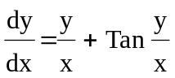 | L2 | CO1 | [2M]
2 | Solve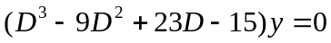 | L3 | CO2 | [2M]
3 | Find the complete solution of 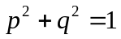 | L5 | CO3 | [2M]
4 | Classify the partial differential equation 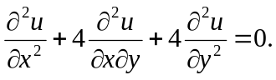 | L1 | CO4 | [2M]
5 | Evaluate 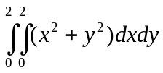 | L2 | CO5 | [2M]
6 | Evaluate 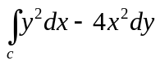along the parabola y=x² from (0,0) to (1,2) . | L3 | CO6 | [2M]
7 | Find the integrating factor of 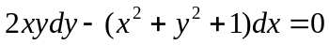 | L1 | CO1 | [2M]
8 | Find the complete solution of | L4 | CO3 | [2M]
9 | State Green’s Theorem. | L1 | CO6 | [2M]
10 | Solve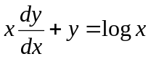 | L3 | CO1 | [2M]

Part – B Max.Marks:50
ANSWER ANY FIVE QUESTIONS. EACH QUESTION CARRIES 10 MARKS.

 |  |  | BCLL | CO(s) | Marks
11. | a) | Solve 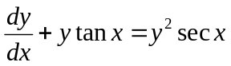 | L2 | CO1 | [5M]
 | b) | A body is originally at 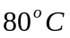 and it cools down to 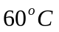 in 20 min. If the temperature of the air is 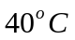,then find the temperature of body after 40min. | L3 | CO1 | [5M]
12. | a) | Solve 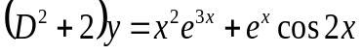 | L5 | CO2 | [5M]
 | b) | Solve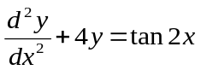 by the method of variation of parameters | L3 | CO2 | [5M]
13. | a) | Solve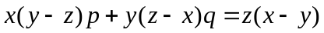 | L3 | CO3 | [5M]
 | b) | Solve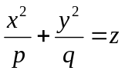 | L5 | CO3 | [5M]
14. |  | Solve 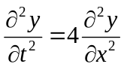 when y(0,t)=0,y(2,t)=0 and  y(x,0)=x-x². | L4 | CO4 | [10M]
15. | a) | Evaluate by changing the order of integration 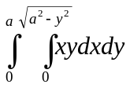 | L3 | CO5 | [5M]
 | b) | Evaluate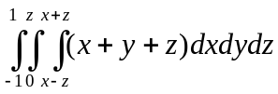 | L3 | CO5 | [5M]
16. |  | Using Gauss divergence theorem, evaluate 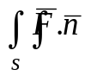ds  where F = xi+yj+zk and S is the cube bounded by  x=0, y=0, z=0, x=a, y=a, z=a. | L4 | CO6 | [10M]
17. | a) | Find the orthogonal trajectory of families of semi cubical parabolas 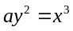,where a is a parameter | L3 | CO1 | [4M]
 | b) | Solve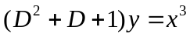 | L3 | CO2 | [3M]
 | c) | Form a partial differential equation by eliminating arbitrary constants  a,b from 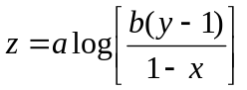 | L1 | CO3 | [3M]
18. | a) | Solve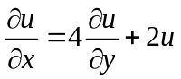 by using method of separation of variables. | L3 | CO4 | [5M]
 | b) | Verify Green’s theorem to evaluate 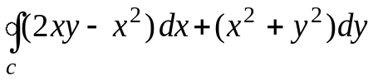where ‘c’ is the closed curve of the region bounded by y = x² and y² =x. | L3 | CO6 | [5M]

-- 00 -- 00 –

